## 

**Macro-Economic Data Summery**

*As of 9 months data of FY 2081/82*



Prepared By:

Research Department

Sanima Capital Limited

*sanimacapital@sanimabank.com*

# Economic Report as of 9 months

The Nepal Rastra Bank (NRB) has published the current macroeconomic and financial situation of Nepal based on Nine -month data of FY 2081/82. The major macroeconomic indicators for Nine-month data of FY 2081/82, which provide crucial insights into Nepal's economy,

## Inflation and Price Stability

The inflation chart reveals a significant moderation in Nepal's inflationary pressures in recent years. Looking at 2081/82 (2024/25), inflation has stabilized at 3.39% in Chait (mid-March to mid-April), continuing a downward trajectory from 6.05% in Mangsir (mid-November to mid-December). This represents one of the lowest inflation readings in recent years and aligns with the data from the Nepal Rastra Bank report showing y-o-y consumer price inflation at 3.39% in mid-April 2025

Peak inflation occurred in 2072/73, then fell and stayed moderate for several years. Inflation climbed again around 2079/80–2080/81, reflecting both domestic and global cost pressures. The most recent year (2081/82) shows a partial easing but remains above the lowest levels seen in the mid-2070s.

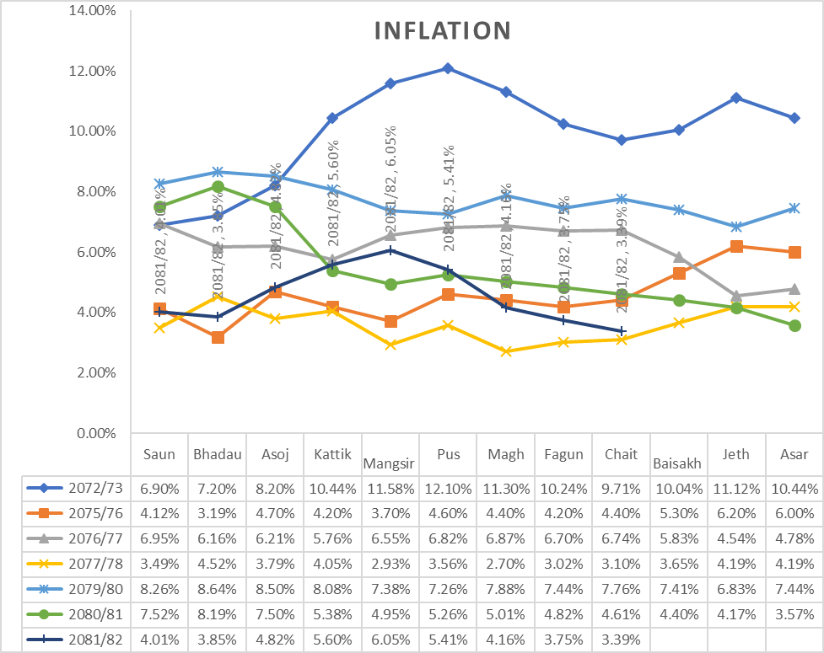

## Inflation between Nepal and India.

|  |  |  |  |  |  |  |  |  |  |  |  |  |
| --- | --- | --- | --- | --- | --- | --- | --- | --- | --- | --- | --- | --- |
| **Mid-Month** | **2021/22** | |  | **2022/23** | |  | **2023/24** | |  | **2024/25** | |  |
|  | **Nepal** | **India** | **Deviation** | **Nepal** | **India** | **Deviation** | **Nepal** | **India** | **Deviation** | **Nepal** | **India** | **Deviation** |
| August | 4.35 | 5.30 | -0.95 | 8.26 | 7.00 | 1.26 | 7.52 | 6.83 | 0.69 | 4.09 | 3.65 | 0.44 |
| September | 3.49 | 4.35 | -0.86 | 8.64 | 7.41 | 1.23 | 8.19 | 5.02 | 3.17 | 3.86 | 5.49 | -1.63 |
| October | 4.24 | 4.48 | -0.24 | 8.50 | 6.77 | 1.73 | 7.50 | 4.87 | 2.63 | 4.82 | 6.21 | -1.39 |
| November | 6.04 | 4.91 | 1.13 | 8.08 | 5.88 | 2.20 | 5.38 | 5.55 | -0.17 | 5.60 | 5.48 | 0.12 |
| December | 7.11 | 5.66 | 1.45 | 7.38 | 5.72 | 1.66 | 4.95 | 5.69 | -0.74 | 6.05 | 5.22 | 0.83 |
| January | 5.65 | 6.01 | -0.36 | 7.26 | 6.52 | 0.74 | 5.26 | 5.10 | 0.16 | 5.41 | 4.31 | 1.10 |
| February | 6.24 | 6.07 | 0.17 | 7.88 | 6.44 | 1.44 | 5.01 | 5.09 | -0.08 | 4.16 | 3.61 | 0.55 |
| March | 7.14 | 6.95 | 0.19 | 7.44 | 5.66 | 1.78 | 4.82 | 4.85 | -0.03 | 3.75 | 3.34 | 0.41 |
| April | 7.28 | 7.79 | -0.51 | 7.76 | 4.70 | 3.06 | 4.61 | 4.83 | -0.22 | 3.39 | 3.16 | 0.23 |
| May | 7.87 | 7.04 | 0.83 | 7.41 | 4.31 | 3.10 | 4.40 | 4.80 | -0.40 |  |  |  |
| June | 8.56 | 7.01 | 1.55 | 6.83 | 4.87 | 1.96 | 4.17 | 5.08 | -0.91 |  |  |  |
| July | 8.08 | 6.71 | 1.37 | 7.44 | 7.44 | 0.00 | 3.57 | 3.60 | -0.03 |  |  |  |
| **Average** | **6.32** | **6.02** | **0.31** | **7.74** | **6.06** | **1.68** | **5.44** | **5.11** | **0.34** | **4.57** | **4.50** | **0.07** |

The data reveals a significant convergence between Nepal and India's inflation rates in 2024/25, with the average differential narrowing to just 0.07 percentage points, compared to 0.34 points in 2023/24 and 1.68 points in 2022/23. This convergence is particularly noteworthy given Nepal's high import dependency on India (60% of total imports).

The inflation convergence between Nepal and India represents a positive development for Nepal's macroeconomic stability.

## Trade Overview and Analysis

During the nine months of 2024/25, merchandise exports increased 65.2 percent to Rs.188.20 billion against a decrease of 3.7 percent in the same period of the previous year. Destination wise, exports to India, China and other countries increased 92.6 percent, 6.7 percent and 5.8 percent respectively.

Exports of soya bean oil, polyester yarn and thread, tea, jute goods, and rosin, among others increased whereas export

During the nine months of 2024/25, merchandise imports increased 12.2 percent to Rs.1309.53 billion against a decline of 2.8 percent a year ago. Destination-wise, imports from India, China and other countries increased 7.7 percent, 14.4 percent and 24.9 percent respectively. Imports of crude soya bean oil, rice/paddy, transport equipment, vehicle and spare parts, edible oil, sponge iron, among others increased whereas imports of petroleum products, crude palm oil, aircraft spare parts, chemical fertilizer, and writing and printing paper among others decreased in the review period.

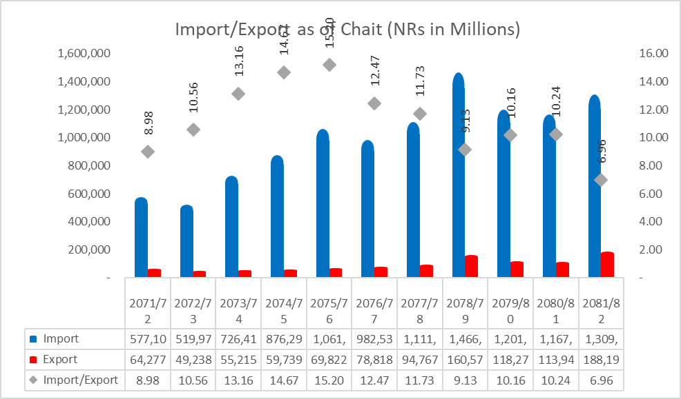

The chart displays the trends in Nepal's import and export values over fiscal years, along with the export-import ratio. Imports have consistently outpaced exports, contributing to a persistent trade deficit.

While exports have shown growth, especially in recent years, the widening gap between imports and exports highlights Nepal's heavy reliance on imported goods.

The significant decline in global oil prices has played a crucial role in Nepal's import dynamics. Brent crude oil prices fell 28.23% to $66.83 per barrel in mid-April 2025 from $93.12 per barrel a year ago. This substantial decrease has directly impacted Nepal's import bill, as petroleum products consistently represent one of the country's largest import categories. Total imports increased to Rs.1309.53 billion despite the decline in petroleum product imports. Other major import categories showed increases (crude soya bean oil, rice/paddy, transport equipment). The decrease in petroleum product imports helped contain what could have been a much larger trade deficit.

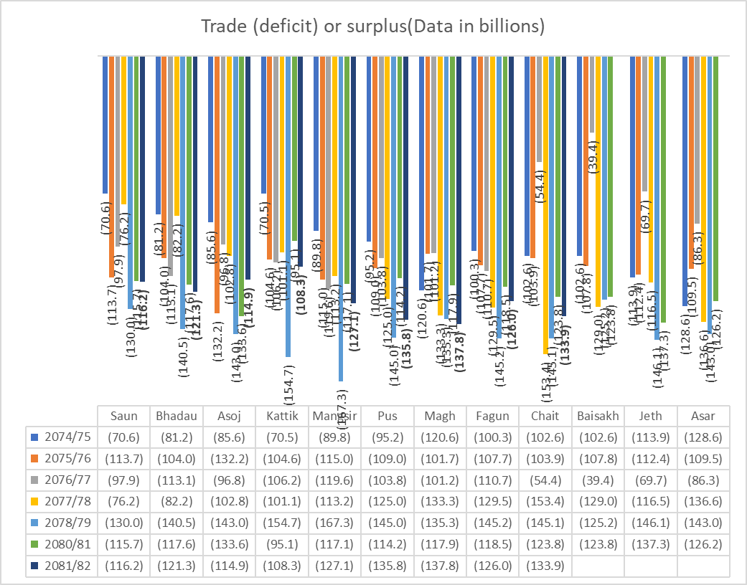

This table presents monthly trade deficit data across fiscal years 2074/75 to 2081/82

Across all months and years, the trade deficit is evident, with higher deficits in certain months like Mangsir and Chait. The data also suggests some improvement in deficits during months like Jestha and Asar, possibly indicating seasonal impacts on trade. Total trade deficit increased 6.4 percent to Rs.1121.34 billion during the nine months of 2024/25. Such a deficit had decreased 2.8 percent in the corresponding period of the previous year.

## Monthly Remittances (Data in billions)

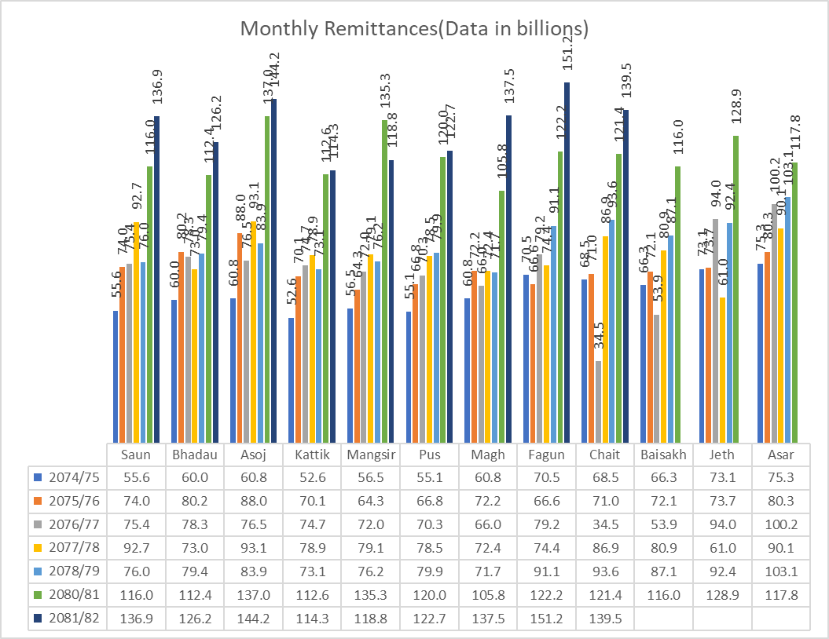

Remittance as of Chait 2081/82: YOY growth 10.03% TTM growth 11.01% Last year month Vs this year month Growth 14.94%

The number of Nepali workers, both institutional and individual, taking first-time approval for foreign employment stands at 358,222 and taking approval for renew entry stands at 249,652. In the previous year, such numbers were 327,842 and 211,226 respectively.

The upward trend underscores remittances' critical role in stabilizing the Nepalese economy and supporting household expenditures. This positive outlook also benefits key sectors like banking, construction, and consumer industries, contributing to economic growth and stock market performance. These remittance flows have played a crucial role in maintaining Nepal's external sector stability, contributing significantly to the country's foreign exchange earnings and helping to maintain a surplus in the current account.

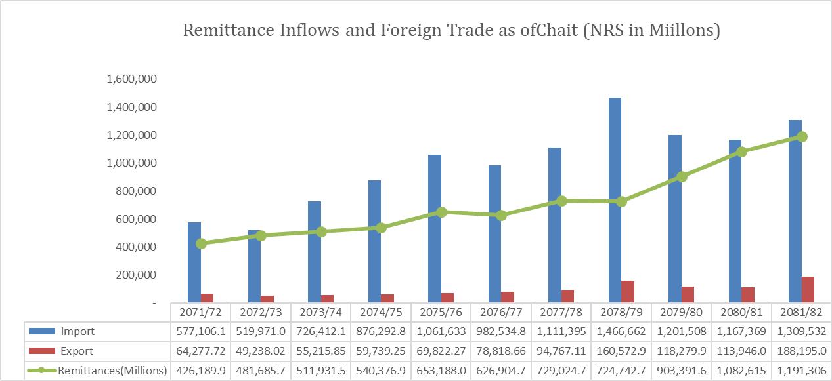

The tourism sector in Nepal shows signs of recovery following the pandemic, driven by easing travel restrictions and revived global mobility.

## Current Account (Monthly) (Data in billions)

|  |  |  |  |  |  |  |  |  |  |  |  |  |  |
| --- | --- | --- | --- | --- | --- | --- | --- | --- | --- | --- | --- | --- | --- |
| **YOY** | **Shrawan** | **Bhadra** | **Ashoj** | **Kartik** | **Mangsir** | **Poush** | **Magh** | **Falgun** | **Chait** | **Baisakh** | **Jestha** | **Ashar** | **Total** |
| 2073/74 | (2.3) | (8.8) | 9.1 | 3.8 | 1.6 | (4.6) | (9.6) | 4.4 | (4.0) | 2.8 | 4.6 | (7.1) | **(10.1)** |
| 2074/75 | (6.0) | (13.8) | (5.8) | (23.5) | (15.1) | (33.7) | (44.3) | (12.9) | (17.7) | (19.4) | (18.2) | (37.3) | **(247.6)** |
| 2075/76 | (25.2) | (10.0) | (46.6) | (6.9) | (30.7) | (32.8) | (14.1) | (24.9) | (13.3) | (17.0) | (27.3) | (16.6) | **(265.4)** |
| 2076/77 | (9.4) | (12.4) | (5.4) | (10.1) | (33.0) | (14.4) | (27.4) | (12.8) | (10.6) | 29.8 | 34.1 | 37.9 | **(33.8)** |
| 2077/78 | 25.4 | 0.7 | 8.3 | (13.9) | (41.8) | (28.2) | (52.4) | (46.8) | (58.7) | (39.7) | (46.9) | (39.7) | **(333.7)** |
| 2078/79 | (47.9) | (58.9) | (45.0) | (71.5) | (77.5) | (53.4) | (59.8) | (49.1) | (49.8) | (34.7) | (48.4) | (27.6) | **(623.3)** |
| 2079/80 | (16.3) | (20.9) | 2.9 | (1.1) | (2.5) | 8.4 | (0.2) | (14.7) | (7.5) | (2.9) | (14.7) | (2.8) | **(72.2)** |
| 2080/81 | 13.0 | 10.5 | 35.6 | 37.3 | 43.9 | 21.4 | 0.1 | 5.2 | 12.6 | 13.8 | 7.1 | 20.9 | **221.3** |
| 2081/82 | 30.9 | 18.8 | 62.2 | 31.6 | (2.7) | 7.5 | 18.6 | 13.3 | 30.1 |  |  |  | **210.2** |

The current account remained at a surplus of Rs. 210.22 billion in the review period compared to a surplus of Rs.179.83 billion in the same period of the previous year. In the US Dollar terms, the current account registered a surplus of 1.55 billion in the review period against a surplus of 1.35billion in the same period last year.

## Balance on Goods and Services(monthly) (Data in billions)

|  |  |  |  |  |  |  |  |  |  |  |  |  |  |
| --- | --- | --- | --- | --- | --- | --- | --- | --- | --- | --- | --- | --- | --- |
| **YOY** | **Shrawan** | **Bhadra** | **Ashoj** | **Kartik** | **Mangsir** | **Poush** | **Magh** | **Falgun** | **Chait** | **Baisakh** | **Jestha** | **Ashar** | **Total** |
| 2073/74 | (64.8) | (72.2) | (61.1) | (69.2) | (70.6) | (74.8) | (84.2) | (65.7) | (86.3) | (74.0) | (82.0) | (88.1) | **(892.9)** |
| 2074/75 | (71.5) | (84.0) | (84.0) | (84.8) | (86.8) | (89.1) | (99.7) | (97.7) | (101.0) | (98.4) | (109.7) | (128.2) | **(1,134.9)** |
| 2075/76 | (113.9) | (110.0) | (134.2) | (93.8) | (106.9) | (109.3) | (99.9) | (106.2) | (100.6) | (104.0) | (110.2) | (111.1) | **(1,300.1)** |
| 2076/77 | (97.6) | (111.6) | (98.5) | (98.0) | (117.7) | (101.8) | (99.5) | (107.6) | (52.4) | (35.8) | (67.8) | (73.7) | **(1,061.9)** |
| 2077/78 | (75.7) | (82.3) | (104.1) | (102.4) | (115.9) | (126.9) | (136.0) | (132.9) | (159.7) | (131.4) | (115.7) | (145.3) | **(1,428.3)** |
| 2078/79 | (134.6) | (142.2) | (143.3) | (155.4) | (168.0) | (147.5) | (141.5) | (152.0) | (155.7) | (131.8) | (153.1) | (145.0) | **(1,770.1)** |
| 2079/80 | (120.9) | (128.5) | (109.3) | (112.7) | (117.0) | (114.1) | (116.2) | (136.2) | (138.5) | (121.4) | (139.0) | (129.0) | **(1,483.0)** |
| 2080/81 | (121.1) | (124.4) | (128.7) | (86.7) | (110.5) | (120.1) | (117.8) | (124.3) | (129.3) | (121.5) | (139.5) | (119.7) | **(1,443.6)** |
| 2081/82 | (125.5) | (126.7) | (100.9) | (102.5) | (140.5) | (133.8) | (138.6) | (146.5) | (131.9) |  |  |  | **(1,147.0)** |

## BOP (monthly) (Data in billions)

|  |  |  |  |  |  |  |  |  |  |  |  |  |  |
| --- | --- | --- | --- | --- | --- | --- | --- | --- | --- | --- | --- | --- | --- |
| **YOY** | **Shrawan** | **Bhadra** | **Ashoj** | **Kartik** | **Mangsir** | **Poush** | **Magh** | **Falgun** | **Chait** | **Baisakh** | **Jestha** | **Ashar** | **Total** |
| 2073/74 | (2.1) | (1.4) | 23.2 | 2.3 | 6.8 | 16.2 | (8.1) | 13.1 | 0.6 | 3.2 | 20.4 | 7.9 | **82.1** |
| 2074/75 | (3.3) | (2.6) | 10.1 | (1.9) | (7.9) | (1.2) | (11.6) | (6.5) | 10.1 | (4.3) | 14.6 | 5.3 | **1.0** |
| 2075/76 | (24.8) | (0.7) | (10.0) | (21.9) | (28.0) | 21.6 | 14.4 | (9.7) | (5.7) | (3.5) | (22.6) | 23.4 | **(67.4)** |
| 2076/77 | 6.0 | 2.8 | 5.6 | 12.9 | (4.0) | 3.4 | (5.0) | 16.2 | (1.2) | 84.3 | 58.5 | 103.0 | **282.4** |
| 2077/78 | 51.5 | 16.2 | 33.5 | 9.6 | (4.2) | 18.4 | (27.6) | (29.4) | (25.5) | (34.8) | (22.9) | 16.4 | **1.2** |
| 2078/79 | (38.7) | (44.7) | 7.3 | (74.2) | (44.6) | (46.2) | (5.8) | (11.6) | (9.6) | (20.2) | 18.7 | 14.5 | **(255.3)** |
| 2079/80 | (22.6) | (1.0) | 36.1 | 7.6 | 25.8 | 51.2 | 36.1 | 14.9 | 32.1 | 34.5 | 14.3 | 61.5 | **290.5** |
| 2080/81 | 32.9 | 20.7 | 45.5 | 48.0 | 63.5 | 62.9 | 24.2 | 29.8 | 37.6 | 27.5 | 33.0 | 76.8 | **502.5** |
| 2081/82 | 40.9 | 60.9 | 83.2 | 20.8 | 19.5 | 23.9 | 35.1 | 26.0 | 35.9 |  |  |  | **346.2** |

Balance of Payments (BOP) remained at a surplus of Rs.346.23 billion in the review period compared to a surplus of Rs.365.16 billion in the same period of the previous year. In the US Dollar terms, the BOP remained at a surplus of 2.55 billion in the review period compared to a surplus of 2.75 billion in the same period of the previous year

The combined effect of accelerating exports and robust remittances has supported the balance of payments surplus of Rs.346.23 billion and foreign exchange reserves of $17.63 billion.

## Foreign Exchange Reserves:

As of 2024/25-April Import Capacity in Months-Merchandise is 17.1 Months and Import Capacity in Months-Merchandise & Services Is 14.2 Months far exceeding the international benchmark of 6 months considered adequate for external stability.

Nepal's foreign exchange position has strengthened significantly, with gross reserves reaching $17.63 billion in mid-April 2025, a 15.4% increase from $15.27 billion in mid-July 2024. In local currency terms, reserves grew even more substantially by 18.9% to Rs.2426.84 billion, reflecting both accumulation and valuation effects.

The five-year trend (2021-2025) shows remarkable recovery and growth, with reserves reaching historical highs after a temporary decline in 2022. Particularly noteworthy is the acceleration in reserve accumulation since 2023, with the 2025 level ($17.63 billion) representing approximately a 50% increase from the 2022 low point ($9.5 billion).

## Reserve Composition and Distribution

The reserve structure reveals important institutional developments:

1. Central Bank Holdings: Nepal Rastra Bank (NRB) holds the majority of reserves at Rs.2136.46 billion (approximately $15.52 billion), a 15.6% increase from mid-July 2024.
2. Banking Sector Holdings: Commercial banks and financial institutions have significantly increased their reserve holdings by 50.8% to Rs.290.38 billion (approximately $2.11 billion), indicating growing internationalization of Nepal's banking system.
3. Currency Composition: Indian currency constitutes 20.4% of total reserves, an appropriate level given that 60% of Nepal's imports come from India, though this suggests some potential for optimization.

The ratio of reserves-to-GDP, reserves-to-imports and reserves-to-M2 stood at 39.7 percent, 118.7 percent and 32.8 percent respectively in mid-April 2025. Such ratios were 35.8 percent, 108.6 percent and 29.3 percent respectively in mid-July 2024.

## Interest Rates:

## 12 months interest rate change

|  |  |  |  |
| --- | --- | --- | --- |
| Summary of Publish rate | 2080/81 | 2081/82 | % change |
| Chait | Chait |  |
| Ib Rate (Interest Rate) | 3.07% | 3.00% | -2.4% |
| Deposit Rate | 6.53% | 4.45% | -31.9% |
| Lending Rate | 10.55% | 8.22% | -22.1% |
| Base Rate | 8.51% | 6.29% | -26.1% |
| Deposit Rate (Db) | 7.58% | 5.22% | -31.2% |
| Lending Rate (Db) | 12.17% | 9.59% | -21.2% |
| Base Rate (Db) | 10.41% | 8.34% | -19.8% |
| Deposit Rate (Fin) | 8.82% | 6.24% | -29.3% |
| Lending Rate (Fin) | 13.36% | 10.40% | -22.1% |
| Base Rate (Fin) | 12.02% | 9.17% | -23.7% |

The table reflects a notable decline across key interest rate categories from FY 2080/81 to FY 2081/82.

These reductions in interest rates are likely to stimulate credit growth and investment, particularly in sectors such as manufacturing, construction, and real estate. While borrowers benefit from reduced financing costs, savers face lower returns on deposits, which may encourage a shift toward alternative investments like the stock market or real estate. The decline in interest rates also supports the stock market by increasing liquidity and lowering the cost of capital for businesses.

The data reveals a dramatic decline in Nepal's interest rate environment over the past 12 months. Commercial banks have seen deposit rates fall by 31.9% (from 6.53% to 4.45%) and lending rates decline by 22.1% (from 10.55% to 8.22%), creating a significant structural shift in the financial markets. Development banks and finance companies have experienced similar substantial reductions across all their rate metrics.

Historically, a decrease in interest rates has often led to an increase in stock market indices. Lower interest rates reduce borrowing costs for companies, encouraging them to invest and expand their operations. Deposits at BFIs increased 5.7 percent and private sector credit increased 7.1 percent While Nepal has experienced a significant decline in interest rates across the financial spectrum, private sector credit growth has shown a somewhat restrained response. Private sector credit from Banks and Financial Institutions (BFIs) increased by Rs.361.03 billion (7.1%) during the review period, which represents an improvement from the 4.6% growth (Rs.222.21 billion) in the corresponding period of the previous year, but remains modest relative to the substantial interest rate cuts. This slowdown in deposit growth could actually be beneficial in reducing excess liquidity pressures on banks. A significant development is the reduction in commercial banks' average base rate, indicating an easing of borrowing costs, although the full impact on businesses and consumers is yet to materialize.

Plot of NEPSE Monthly return vs change in rate of deposit.

X= Deposit Rate 1-month Change%

Y= Nepse Monthly return%

The chart shows a clear negative correlation between changes in deposit rates (X-axis) and NEPSE Monthly returns (Y-axis). This is confirmed by the downward sloping trendline and the equation displayed in the top right corner: y = -1.2474x - 0.0043, with an R² value of 0.7237

* Negative correlation: When deposit rates increase (positive X values), stock market returns tend to decrease (negative Y values). Conversely, when deposit rates decrease (negative X values), stock market returns tend to increase (positive Y values).
* Strength of relationship: The R² value of 0.7237 indicates a fairly strong correlation, suggesting that approximately 72.37% of the variation in NEPSE Monthly returns can be explained by changes in deposit rates.
* Slope coefficient: The -1.2474 coefficient means that for every 1% increase in deposit rates, NEPSE returns tend to decrease by about 1.25% on average.

## Market Capitalization of Listed Companies (Rs million)

|  |  |  |  |  |  |  |
| --- | --- | --- | --- | --- | --- | --- |
| **Heading** | **2023** | | **2024** | | **2025** | |
| **Value** | **Share %** | **Value** | **Share %** | **Value** | **Share %** |
| *Commercial Banks* | 968966.6 | 34.4 | 817928.7 | 25.5 | 1046408.4 | 23.6 |
| *Development Banks* | 130856.6 | 4.7 | 145680.4 | 4.5 | 198850.2 | 4.5 |
| *Finance Companies* | 53274.9 | 1.9 | 65073.2 | 2.0 | 81736.3 | 1.8 |
| *Microfinance* | 265780.9 | 9.4 | 299511.3 | 9.3 | 364583.5 | 8.2 |
| *Insurance Companies* | 375406.7 | 13.3 | 504487.5 | 15.7 | 637546.0 | 14.4 |
| Manufacturing & Processing | 109567.0 | 3.9 | 229065.3 | 7.1 | 238005.8 | 5.4 |
| Hotel | 58818.1 | 2.1 | 92502.2 | 2.9 | 116526.5 | 2.6 |
| Trading | 12639.2 | 0.4 | 16247.8 | 0.5 | 257676.5 | 5.8 |
| Investment | 193990.05 | 6.9 | 235738.3 | 7.3 | 351051.4 | 7.9 |
| Hydro Power | 405864.8 | 14.4 | 477568.2 | 14.9 | 668176.3 | 15.1 |
| Others | 238388.8 | 8.5 | 328205.3 | 10.2 | 464840.1 | 10.5 |
| **Total** | **2813553.73** | **100.0** | **3212008.14** | **100.0** | **4425401.00** | **100.00** |

The overall market capitalization shows robust growth, expanding from Rs. 2813,553.73 million in 2023 to Rs. 4425,401.00 million in 2025, representing a significant 57.3% increase over the period. Commercial Banks, while maintaining their position as the largest sector, show a declining market share trend from 34.4% to 23.6%, suggesting potential market rebalancing.

Emerging Sectors: Several sectors have significantly increased their market share:

* Insurance Companies: Increased from 13.3% to 14.4% (2023-2025)
* Hydropower: Maintained strong presence at 15.1% (slight increase from 14.4%)
* Investment Companies: Grew from 6.9% to 7.9%
* Trading Companies: Dramatic increase from 0.4% to 5.8%

## Summary of Monetary Operations.

|  |  |  |  |  |  |
| --- | --- | --- | --- | --- | --- |
| Details | 2021/22 | 2022/23 | 2023/24 | 2023/24  Mid-Apr | 2024/25  Mid-Apr |
| A. Liquidity Injection | **9,702,410.00** | **5,518,186.20** | **804,762.58** | **795,212.58** | **2,700.00** |
| 1. Repo | 270,000.00 | 316,500.00 | - | - | - |
| 2. Outright Purchase | 55,915.90 | 89,700.00 | - | - | - |
| 3. Repo Auction * | 206,388.00 | 97,972.60 | - | - | - |
| 4. Standing Liquidity Facility | 9,170,106.10 | 2,727,112.30 | 1,200.00 | 1,200.00 | - |
| 5. OLF | - | 2,286,901.30 | 803,562.58 | 794,012.58 | 2,700.00 |
| B. Liquidity Absorption | **60,000.00** | **108,200.00** | **4,673,600.00** | **1,561,400.00** | **17,186,150.00** |
| 1. Reverse Repo | 28,350.00 | 88,200.00 | - | - | - |
| 2. Outright Sale | - | - | - | - | - |
| 3. Deposit Collection Auction | 31,650.00 | 20,000.00 | 1,151,250.00 | 693,050.00 | 2,212,050.00 |
| 4. Deposit Collection Auction * | - | - | - | - | - |
| 5. Standing Deposit Facility | - | - | 3,522,350.00 | 868,350.00 | 14,974,100.00 |
| C. Net Liquidity Injection (+) / Absorption (-) | **9,642,410.00** | **5,409,986.20** | **(3,868,837.42)** | **(766,187.42)** | **(17,183,450.00)** |

* Transaction under Interest Rate Corridor

The table outlines monetary operations in Rs. millions, showing a significant shift in liquidity management over recent years. The data shows a dramatic shift from substantial net liquidity injection in earlier years to unprecedented liquidity absorption in the current period, reflecting a complete reversal in monetary stance.

### Quantitative Analysis

* Net Liquidity Position: In 2024/25 (mid-April), NRB absorbed a record Rs.17,183,450 million, representing the largest liquidity withdrawal in the five-year period examined. This contrasts sharply with the net injections of Rs.9,642,410 million in 2021/22 and Rs.5,409,986.20 million in 2022/23.
* Absorption Mechanisms: The 2024/25 liquidity absorption has been achieved primarily through:
  + Standing Deposit Facility: Rs.14,974,100 million (87.1% of total absorption)
  + Deposit Collection Auction: Rs.2,212,050 million (12.9% of total absorption)
* Injection Reduction: Liquidity injection has been drastically reduced to just Rs.2,700 million in 2024/25 (mid-April), compared to Rs.795,212.58 million in the same period last year—a 99.7% decrease.
* Historical Context: The progressive tightening is evident in the transition from net injection of Rs.9,642,410 million in 2021/22 to net absorption of Rs.766,187.42 million in 2023/24, and now to the massive Rs.17,183,450 million absorption in 2024/25.

Despite recent declines in market rates, the aggressive liquidity absorption suggests NRB may be attempting to establish a floor for interest rates, potentially limiting further significant rate decreases. The unprecedented scale of liquidity absorption, combined with generally positive economic indicators, suggests NRB is taking preemptive measures to ensure sustainable growth without financial imbalances.

## Fiscal situation

## Revenue Performance Analysis

Nepal's revenue collection performance shows a concerning trajectory over the five-year period. Revenue collection as a percentage of budgeted amounts has declined substantially from 73.8% in FY 2020/21 to 62.8% in FY 2024/25 (as of 06/May/2025). This represents a 11-percentage point deterioration in revenue mobilization efficiency.

The decline has been particularly pronounced between FY 2022/23 (52.2%) and FY 2023/24 (55.6%), followed by a modest improvement to 62.8% in the current fiscal year. This persistent underperformance in revenue collection relative to budget targets suggests structural challenges in Nepal's tax administration or overly optimistic revenue projections.

## Expenditure Execution Patterns

Total expenditure execution shows a similar downward trend, declining from 53.9% in FY 2020/21 to 50.1% in FY 2024/25. This consistent under-execution of budgeted expenditure has several components:

Capital Expenditure: Capital spending execution has remained problematic, though it has shown some improvement from the low of 30.3% in FY 2021/22 to 32.4% in FY 2024/25. The persistent under-execution of capital expenditure (consistently below 35% of budgeted amounts) reflects Nepal's continued challenges in implementing development projects.

Recurrent Expenditure: Recurrent expenditure execution has remained relatively stable, ranging between 63.8% and 66.2% over the five-year period, with the current year at 64.8%. This category consistently shows the highest execution rate among expenditure types.

Financing Expenditure: The most dramatic change is observed in financing expenditure, which has surged from 38.6% execution in FY 2020/21 to 72.0% in FY 2024/25. This significant increase suggests growing debt servicing requirements or financial investments

This growing expenditure base, coupled with volatile revenue collection and rising financing costs, suggests potential fiscal sustainability challenges. The current trajectory indicates a need for strategic intervention to boost revenue collection efficiency and optimize expenditure allocation, particularly in managing the growing financing burden.

# Conclusion

The monetary policy stance has shifted towards accommodation, with a sharp decline in interest rates across the banking sector. For instance, lending rates and deposit rates have dropped significantly in fiscal year 2081/82, making borrowing cheaper and encouraging credit growth. Liquidity operations reflect this trend, with the central bank absorbing excess liquidity aggressively to manage inflation and ensure financial stability. However, while reduced rates benefit businesses and stimulate investment, lower deposit rates discourage savings and could push investors toward alternative assets like the stock market or real estate. This highlights the need for balance to avoid unintended inflationary risks.

Significant reductions in deposit, lending, and treasury rates indicate an accommodative monetary policy stance. Encourages borrowing for consumption and investment, supporting economic growth. The significant declining interest rates across various financial instruments indicates a more accommodative monetary environment, which is generally favorable for the stock market. Lower borrowing costs can lead to increased business investment and consumer spending, potentially driving corporate earnings and stock prices higher, although the full impact on businesses and consumers is yet to materialize.

However, very low credit growth combined with excess liquidity, particularly driven by an increase in remittances, can Also lead to a complex set of economic challenges, including downward pressure on interest rates, potential asset bubbles, reduced bank profitability, and difficulties in managing inflation and economic growth. The overall impact would depend on how effectively these issues are managed by the central bank and other economic policymakers.

Despite these positive developments, fiscal execution remains challenging with revenue collection at 62.8% of budgeted amounts and capital expenditure execution at just 32.4%. The increasing execution of financing expenditure (72.0%) suggests growing debt service requirements that could constrain fiscal flexibility.

Investors may focus on sectors like, hydropower, and consumer goods, benefiting from low borrowing costs and increased remittance-fueled consumption. However, uncertainty surrounding liquidity management and external vulnerabilities may result in cautious investor behavior and moderate market performance in the near term. The current economic recovery, while promising, remains fragile and could easily be derailed without decisive policy action. Success will depend on the government's ability to balance short-term stability with long-term structural reforms, particularly in strengthening the financial sector and fiscal management.

## Disclaimer:

• *This report is based on 9-month Macro Economic and Financial data for FY 2081/82, published by Nepal Rastra Bank (NRB) and is intended for informational purposes only. Any decision made based on this report are solely at the viewer discretion.*